

**Insert School Logo**

**Semester One**

**Task 2 Test 2023**

**Question/Answer booklet**

**CHEMISTRY**

**UNIT 1**

Name: __________________________________________________________________________________________

Teacher: _______________________________________________________________________________________

***TIME ALLOWED FOR THIS PAPER***

Reading time before commencing work: Five minutes

Working time for the paper: Forty-five minutes

***MATERIALS REQUIRED/RECOMMENDED FOR THIS PAPER***

**To be provided by the supervisor:**

This Question/Answer Booklet

Chemistry Data Book

**To be provided by the candidate:**

Standard items: pens, pencils, eraser or correction fluid, ruler, highlighter.

Special items: calculators satisfying the conditions set by the SCSA for this subject.

***IMPORTANT NOTE TO CANDIDATES***

No other items may be taken into the examination room. It is **your** responsibility to ensure that you do not have any unauthorised notes or other items of a non-personal nature in the examination room. If you have any unauthorised material with you, hand it to the supervisor **before** reading any further.

1. 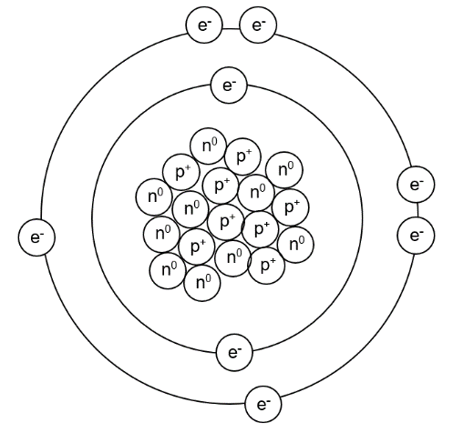Use your knowledge of the atom to complete the table below.[3 marks]

|  |  |  |  |
| --- | --- | --- | --- |
| Sub-atomic particle label | Sub-atomic particle name | Sub-atomic particle charge | Sub-atomic particle weight |
| e- |  |  |  |
| p+ |  |  |  |
| n0 |  |  |  |

1. What is the name and symbol of the element in the model?[1 mark]
2. What is the electron configuration of this element? [1 mark]
3. What would be the electron configuration of this element if it was ionised to have a -2 charge? [1 mark]
4. Complete the following table. [5 marks]

|  |  |  |  |
| --- | --- | --- | --- |
| **Symbol** | **Number of protons** | **Number of neutrons** | **Electron configuration** |
| Mg2+  24  12 | 12 |  |  |
|  |  | 0 | 1 |
| S2- |  | 17 |  |
| Ar  33  12  40  18 |  |  | 2, 8, 8 |
|  |  | 16 | 2, 8, 5 |

1. Use the information provided to write a correct symbol for each of the following descriptions. [5 marks]
2. The element that is in group 2 and period 4.
3. A noble gas with exactly 3 occupied electron shells.
4. An element from group 14 that is a non-metal.
5. The element in period 3 that has the largest atomic radius.
6. The element in group 16 that has the highest electronegativity.
7. The isotopes of an element are different atoms that have a different number of neutrons. List one thing that isotopes share and one thing that isotopes have different in regards to their properties. [2 marks]
8. Explain why the relative molecular mass of each element is not identical to those found on the periodic table. [2 marks]
9. Silver atoms consist of 51.4% of the isotope 107Ag and 48.6% of the isotope 109Ag   
   Calculate the relative atomic mass of silver, rounding your answer to 1 decimal place.[3 marks]
10. To determine isotope distributions, a mass spectrometer can be used. A mass spectrometer works in four different phases – ionization, acceleration, deflection, and detection. Describe the first three phases below, explaining why we require each step.
    1. Ionization [2 marks]
    2. Acceleration [2 marks]
    3. Deflection [2 marks]
11. Bohr based his model of the atom on hydrogen, noticing that when heated it emitted coloured light of specific wavelengths. Explain why this occurs. [4 marks]
12. Atomic Absorption Spectroscopy (AAS) can be used to detect incredibly low amounts of various heavy metals. Explain how AAS is different to a typical flame test. [2 marks]
13. At a particular crime scene, a man was found murdered at his kitchen table. Suspected to have died of lead poisoning, a forensic scientist decided to use AAS to construct a calibration curve, shown below
14. Name the type of hallow cathode lamp the scientist would have used and explain why this specific one is needed. [2 marks]
15. The lab results indicated that the water the man drank from had an absorbance reading of 0.35. What was the concentration of lead in the drinking water? [1 mark]
16. The NHMRC has a limit of 0.01 mg/L concentration of lead, with anything above this being considered toxic to humans. Determine whether the man was likely to have died from lead poisoning, explaining why. [2 marks]
17. Describe and explain the trends in electronegativity down the group and across a period in the periodic table. [5 marks]